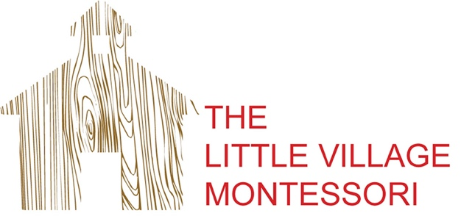

Supply List

- One 3” binder (new students only)
- One pair of soft soled “inside” shoes (with a back that covers the heel)
- One muslin cotton blanket or something similar
- One or two sets of clothes in a Ziploc bag labeled with the child’s name
- Refillable water bottle labeled with the child’s name

Thank you!

-Ms. Mya

